**Email Signature Set Up**

1. In Outlook, click the word “**Outlook**” in the top right corner.
2. Select “**Preferences**.”
3. In the middle of the second line, select “**Signatures**.”

Set up your “**Standard**” signature as noted below. Click the word “**Standard**” and then press “**Edit**” to have the editing box pop up where you can change your signature. Feel free to copy and paste the below to easily change your info.

1. Then add a signature using the “**+**” button. Name it “**Secondary**.” Set up your secondary signature as noted below.
2. Then, set up your Signature settings. For new messages section, select “**Standard**,” and for replies and forwards, select “**Secondary**.”

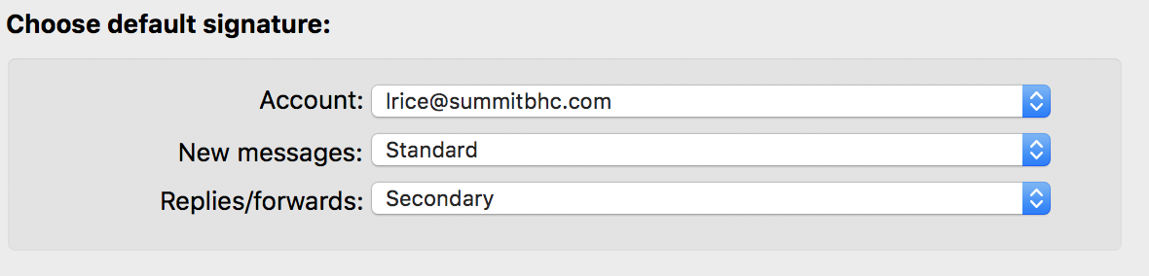

*If you run into any issues, reach out to Laura Rice or Michelle McCabe*

**Standard Signature – New Email**

**Name**

*Title,* Your organization

Office: your-#-here **|** Cell:  your-#-here

Admissions: your-#-here (if relevant)

Fax: your-#-here (if relevant)

Email: [lrice@summitbhc.com](mailto:lrice@summitbhc.com) [**www.yourwebsite.com**](http://www.yourwebsite.com/)

Follow us on:[**Facebook**](https://www.facebook.com/summitbhc/)[**Twitter**](https://twitter.com/SummitBHC)[**LinkedIn**](https://www.linkedin.com/company/3880691/)

**(link your respective social accounts)**

*Improve the lives we touch*

*LOGO (in Quip)*

**Example:**

**Laura Rice**

*Marketing Manager,* Summit Behavioral Healthcare, LLC

Office: 615-550-3701 **|** Cell: 205-873-3293

Email: [lrice@summitbhc.com](mailto:lrice@summitbhc.com)

[**www.summitbhc.com**](http://www.summitbhc.com/)

Follow us on:[**Facebook**](https://www.facebook.com/summitbhc/)[**Twitter**](https://twitter.com/SummitBHC)[**LinkedIn**](https://www.linkedin.com/company/3880691/)

*Improve the lives we touch*

**Secondary Signature – Forwards/Replies**

**Name**

*Title*

Office: your-#-here **|** Cell:  your-#-here

Admissions: your-#-here (if relevant)

[**www.yourwebsite.com**](http://www.yourwebsite.com/)

*Improve the lives we touch*

**Example:**

**Laura Rice**

*Marketing Manager*

Office: 615-550-3701 **|** Cell: 205-873-3293

[**www.summitbhc.com**](http://www.summitbhc.com/)

*Improve the lives we touch*